Geometry Unit Plan
Grades 3-4

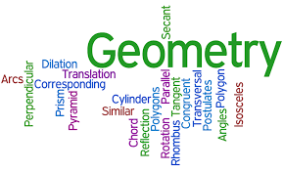

Kristine Gustafson
St. Mary’s Mission School - Red Lake, MN
keg.8993@gmail.com

Kathy McKeown
Lincoln Elementary School - Bemidji, MN
kathy_mckeown@isd31.net

Executive Summary
Students will work with a variety of manipulatives and in numerous situations to practice, explore, and understand many different examples of geometry. Students will have the opportunity to learn useful real-world and problem solving strategies.
The lessons are designed to be used during a normal math period, as supplemental problem solving activities throughout the school day, or as center activities.

Minnesota Standards Addressed:
3rd Grade Standards
3.3.1.1 Identify parallel and perpendicular lines in various contexts, and use them to describe and create geometric shapes, such as right triangles, rectangles, parallelograms and trapezoids.
3.3.1.2 Sketch polygons with a given number of sides or vertices (corners), such as pentagons, hexagons and octagons.
3.3.2.2 Find the perimeter of a polygon by adding the lengths of the sides.
3.3.2.3 Measure distances around objects.
4th Grade Standards
4.3.1.2 Describe, classify and draw quadrilaterals, including squares, rectangles, trapezoids, rhombuses, parallelograms and kites. Recognize quadrilaterals in various contexts.
4.3.2.3 Understand that the area of a two-dimensional figure can be found by counting the total number of same size square units that cover a shape without gaps or overlaps. Justify why length and width are multiplied to find the area of a rectangle by breaking the rectangle into one unit by one unit squares and viewing these as grouped into rows and columns.
4.3.2.4 Find the areas of geometric figures and real-world objects that can be divided into rectangular shapes. Use square units to label area measurements.
4.4.1.1 Use tables, bar graphs, timelines and Venn diagrams to display data sets. The data may include fractions or decimals. Understand that spreadsheet tables and graphs can be used to display data.

MCA Sampler Items:
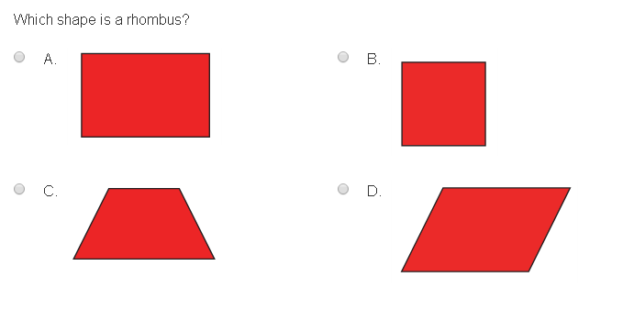

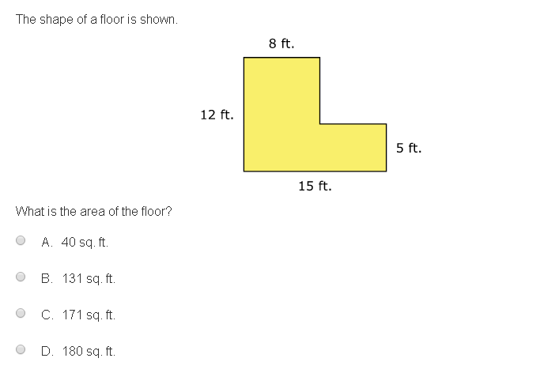
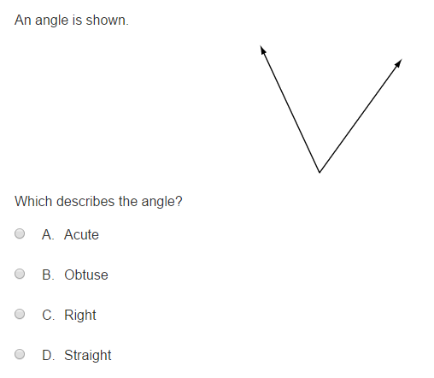

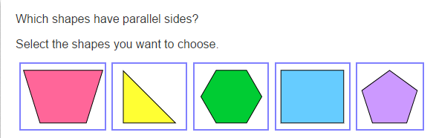
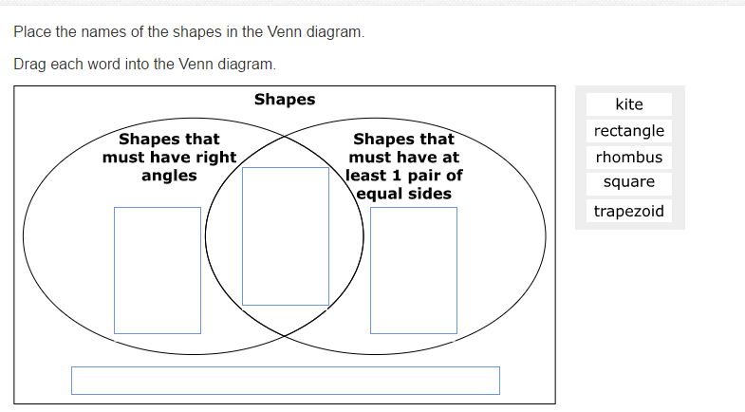
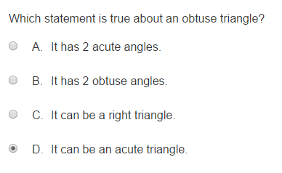
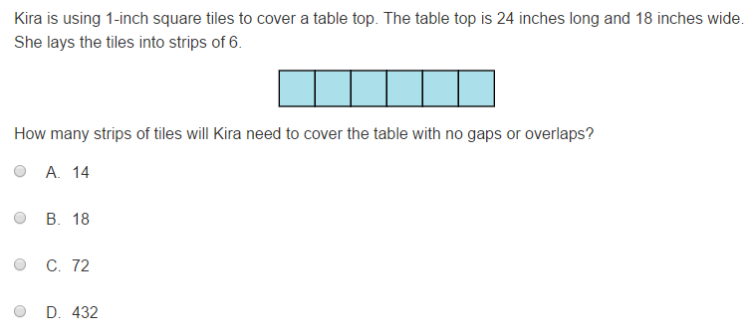

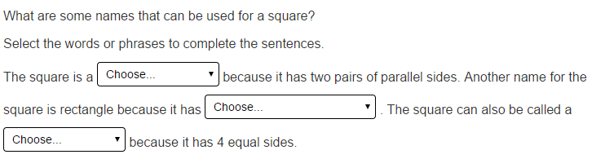

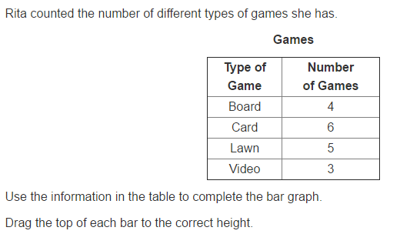
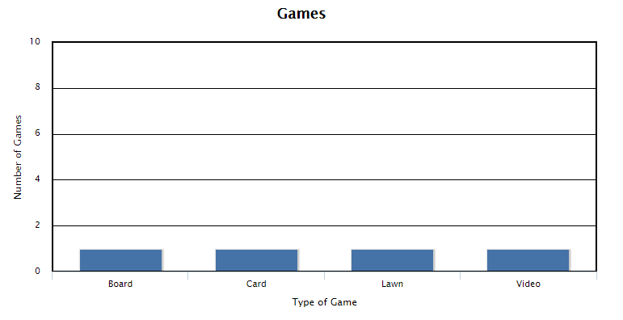
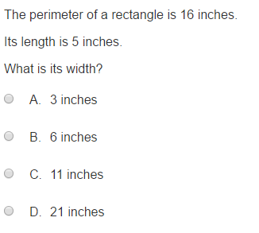

Table of Contents

Topic | Title | Page
Pre-Assessment | Pre-Assessment | 5
Lesson 1 | Gallery Walk | 12
Lesson 2 | Polygons | 13
Lesson 3 | Marshmallow Polygons | 14
Lesson 4 | Regular Polygons | 15
Lesson 5 | Classifying Polygons with Pattern Blocks | 16
Lesson 6 | Classifying Polygons with Straws | 17
Lesson 7 | Investigating Pattern Block Perimeters | 19
Lesson 8 | Area | 20
Lesson 9 | Perimeter and Area Game | 21
Lesson 10 | Perimeter And Area | 22
End-of-Unit Assessment | Post-Assessment | 23

Pre-Assessment
Name:_______________ Date:__________

- What is a polygon? Draw an example.

- What do you know about triangles?

- What makes an angle acute or obtuse?

- Draw and label as many quadrilaterals as you can.

- Find the perimeter of the following shapes: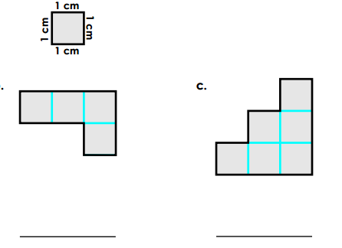

- Find the area of the following shapes:
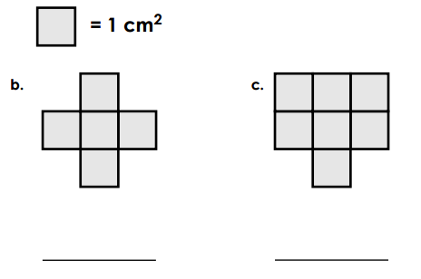
- Circle any shapes with parallel lines. “X” any shapes that have perpendicular lines.

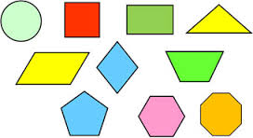

- True or False: A square is a rectangle. Explain your answer.

Lesson 1
Gallery Walk
Standard:
4.3.1.2 Describe, classify and draw quadrilaterals, including squares, rectangles, trapezoids, rhombuses, parallelograms and kites. Recognize quadrilaterals in various contexts.
Learning Targets:
I can describe, classify, and draw polygons.
Materials:
Phone/Camera or Pencil /Paper
Launch: Show students the attached pictures. Have they ever taken the time to notice different shapes in our world? Review some basic shapes with students by having them share the shapes they notice in the pictures (rectangles, squares, triangles, circles, trapezoids, etc.).
Explore: Pair students in small groups. Have students walk around the school taking, or drawing, pictures of different shapes they see. Have each student list what shape he/she saw, and what object they saw it in.
Share: Come back into the classroom and have each group pick a couple of shapes they found, and where they found them.
Summarize: Remind students that shapes are everywhere. Ask students if they noticed any shapes that showed up more often than others, and why they think those shapes would show up more often (rectangles and squares should show up more often as they both have 90 degree angles, which are used in building).

Lesson 2
Polygons
Standard:
4.3.1.2 Describe, classify and draw quadrilaterals, including squares, rectangles, trapezoids, rhombuses, parallelograms and kites. Recognize quadrilaterals in various contexts.
Learning Targets:
I can describe and classify polygons.
Materials:
Pencil
Paper with unlabeled Polygons
Launch:
Ask students what they think a polygon is. Try to lead students to the definition of a polygon being a closed figure made up of straight lines.
Give students examples of letters “V” and “D” and ask if they think either classifies as a polygon. Neither one is a polygon – “V” is not closed, and “D” does not have straight lines only.

Explore:
Have students use the worksheet to label the shapes as “polygon” or “not polygon.”
Share:
Working in pairs, or small groups, have students talk with each other about their answers. Have student groups list any shapes on the board that they had a hard time deciding polygon or not polygon.
Summarize:
Discuss, as a class, the shapes that everyone put up on the board. Have other students try to explain why they chose what they did for that particular shape. Share answers for each shape to be sure everyone got the correct answers.

Lesson 3
Marshmallow Polygons
Standard:
4.3.1.2 Describe, classify and draw quadrilaterals, including squares, rectangles, trapezoids, rhombuses, parallelograms and kites. Recognize quadrilaterals in various contexts.
3.3.1.2 Sketch polygons with a given number of sides or vertices (corners), such as pentagons, hexagons and octagons.
Learning Targets:
I can describe and classify polygons.
I can create polygons with a given number of sides and/or vertices.
Materials:
Mini Marshmallows
Toothpicks
Launch: Ask students to recall the definition of a polygon. They should be able to state that it has straight lines, and is a closed figure.
Explore:
Give students a small handful of marshmallows and toothpicks. Ask students to use the marshmallows and toothpicks to create one or two polygons each. As students are working, walk around to see who you can call on to share their shape.
Share:
Ask students to share their shape. Be sure to tell them it is okay if they do not know what it is called. The class will help them name it. Ask students to share the number of toothpicks they used, as well as the number of marshmallows they used.
Ask students if they know what the toothpick represents in their shape (side). Name the marshmallows as vertices, and be sure they know that one marshmallow is one vertex, versus vertices.
Summarize:
To summarize, have some other students share their shapes, this time naming the toothpicks as number of sides, and the marshmallows as number of vertices.

Lesson 4
Regular Polygons
Standard:
4.3.1.2 Describe, classify and draw quadrilaterals, including squares, rectangles, trapezoids, rhombuses, parallelograms and kites. Recognize quadrilaterals in various contexts.
3.3.1.2 Sketch polygons with a given number of sides or vertices (corners), such as pentagons, hexagons and octagons.
Learning Targets:.
I can classify a polygon as regular or irregular.
I can sketch polygons..
Materials:
Whiteboards
Dry-erase markers and erasers
Launch:
Ask students to make predictions about what makes a polygon “regular” (all interior angles are equal and all side lengths are equal).
Explore:
Have students draw and label examples of both regular and irregular polygons. The teacher should be giving out random numbers for sides and vertices. It is okay if some are unable to be constructed as the students will start to make a connection.
Share:
Each round, have a couple students share their drawings. They should be able to defend their shapes with a label, or a reason as to why it classifies as a polygon. If they need help, the class can step in and assist.
Summarize:
List some attributes, as a class, of what makes a polygon regular. Have students draw examples.

Lesson 5
Classifying Polygons with Pattern Blocks
Standard:
4.3.1.2 Describe, classify and draw quadrilaterals, including squares, rectangles, trapezoids, rhombuses, parallelograms and kites. Recognize quadrilaterals in various contexts.
4.4.1.1 Use tables, bar graphs, timelines and Venn diagrams to display data sets. The data may include fractions or decimals. Understand that spreadsheet tables and graphs can be used to display data.
Learning Targets:
I can describe, classify, and draw polygons.
I can use Venn Diagrams to display data sets.
Materials:
Pattern Blocks
Paper
Pencil
Launch:
Ask students to recall what a Venn Diagram is and how to use two/three different categories to compare items.
Explore:
Ask students to use pattern-blocks to separate shapes into categories that make sense to them. Have students work in pairs and use a Venn Diagram to show their categories. Students should draw a Venn Diagram on a piece of paper, without labeling the categories. Each paper should have either a group number on it, or the names of the students in the group.
Share:
Each group should move together throughout the room, writing down how they think the other groups classified their pattern blocks. Students should get about 30 seconds to a minute at each station before the teacher calls for the groups to rotate.
Summarize:
Starting with group one, have the rest of the class share what they saw in that groups’ Venn Diagram. Once everyone has shared their ideas, have that group share how they sorted their pattern blocks. Continue this until everyone has shared their classifications.

Lesson 6
Classifying Polygons with Straws
Standard:
4.3.1.1 Describe, classify and sketch triangles, including equilateral, right, obtuse and acute triangles. Recognize triangles in various contexts.
4.3.1.2 Describe, classify and draw quadrilaterals, including squares, rectangles, trapezoids, rhombuses, parallelograms and kites. Recognize quadrilaterals in various contexts.
4.3.2.2 Compare angles according to size. Classify angles as acute, right and obtuse.
Learning Targets:
I can compare angles according to size.
I can classify angles as acute, right, and obtuse.
I can describe, classify, and sketch triangles.
I can describe, classify, and sketch quadrilaterals.
Materials:
Pattern Blocks
Pattern-Block Sort page
Twist-ties
Straws
Launch:
Have students recall the different methods they used to sort pattern blocks the day before. Ask students if they can come up with any different ways to sort the blocks. In small groups, have students work together to sort the pattern blocks, using the pattern-block sort page. This should only take a matter of 5 minutes.
Have students make a geometric shape or design using 4 straws and 4 twist-ties. Be sure that they do not bend the straws. Discuss how it is possible to represent 2-D shapes in different ways: with concrete materials (straws and twist-ties, marshmallows and toothpicks, geoboards and rubber bands), with pictures, and with verbal descriptions.
Explore:
Lead students in a discussion about angles, using their straws and twist-ties to create each angle. Remind them that the straws meet at the vertex. Be sure to introduce right, acute, and obtuse angles.
Ask Students to join three straws of different lengths and lay their construction flat on their desks. Ask what this shape is called (Triangle). Then have students work with their other straws to see how many right angles they can make in a triangle. Ask how many right angles there can be in a triangle (one). Ask students if they can name this triangle.
Draw a right triangle and label the vertices X, Y, and Z. Tell students that line segment XY is perpendicular to line segment YZ. Have students identify objects in the classroom that are perpendicular.
Share:
Next, have students create a shape with 4 straws and 4 twist-ties. Ask them what a four-sided shape is called (quadrilateral). As the class discusses different types of quadrilaterals, write those names on the board. Have students create the following shapes using 4 straws and 4 twist-ties: square, rhombus, rectangle, parallelogram, and trapezoid. Discuss the qualities of each of these as a class.
Have students look at a picture of a parallelogram and a kite. Ask how are these two shapes alike (each have 2 pairs of sides the same length). And ask how are they different (the opposite sides are equal in length in a parallelogram, but in a kite, the sides equal in length are next to each other).
Next, ask students to create a quadrilateral with exactly three right angles. Let students struggle for a while, and come to the realization that it is not possible. Have them explain why (as soon as you make the third right angle, the fourth is automatically a right angle as well).

Summarize:
Have students work in small groups to come up with definitions of the shapes they named today (kite, triangle, rectangle, square, trapezoid, parallelogram, rhombus).

Extension: Students can write their definitions on index cards and use these as cards for Geometry Concentration (Memory Game).

Lesson 7
Investigating Pattern-Block Perimeters
Standard:
3.3.2.2 Find the perimeter of a polygon by adding the lengths of the sides.
3.3.2.3 Measure distances around objects.
4.3.1.2 Describe, classify and draw quadrilaterals, including squares, rectangles, trapezoids, rhombuses, parallelograms and kites. Recognize quadrilaterals in various contexts.
Learning Targets:
I can draw quadrilaterals.
I can recognize quadrilaterals in various contexts.
I can find perimeter of a polygon by adding side lengths.
I can measure distance around objects.
Materials:
Pattern Blocks
Paper
Pencil
Launch: Ask students to create any shape using any one shape from their pattern blocks. We chose any one shape versus mixing and matching so that it would be simpler for them to measure perimeter.
Explore: Tell students this is their yard. You want to know how much fencing you need to buy to fence in their entire yard. Have students work with a table partner and discuss ways to measure the outside of their yard.
Share: Have student pairs draw one of their shapes, and write how much fencing they would need to buy to fence in the entire yard. Each group will explain their process to the class. When everyone is done, point out that they found the perimeter of their yard.
Summarize: Explain to students that the perimeter of their yard is counted in units when there is no label of measure. Have students create as many different perimeters as possible using just 1 hexagon, 3 trapezoids, 3 blue rhombuses, and 3 triangles. They should write down their shape, as well as their perimeter, on a piece of paper.

Lesson 8
Area
Standard:
4.3.1.2 Describe, classify and draw quadrilaterals, including squares, rectangles, trapezoids, rhombuses, parallelograms and kites. Recognize quadrilaterals in various contexts.
4.3.2.3 Understand that the area of a two-dimensional figure can be found by counting the total number of same size square units that cover a shape without gaps or overlaps. Justify why length and width are multiplied to find the area of a rectangle by breaking the rectangle into one unit by one unit squares and viewing these as grouped into rows and columns.
4.3.2.4 Find the areas of geometric figures and real-world objects that can be divided into rectangular shapes. Use square units to label area measurements.
Learning Targets:.
I can describe, classify, and draw quadrilaterals.
I can understand that area can be found by counting the total number of same size square units.
I can justify why length and width are multiplied to find area.
Materials: White board
Dry erase markers
Rulers
Launch: Ask students to create any shape, using just squares in their pattern blocks.
Explore: Tell students this is their neighbor’s yard. Their neighbors just built their house and don’t have any grass yet. They are going to put in sod, but they need to know how much they need. Being a neighborly person, each student offers to help out their neighbor. Ask students if they know what information the neighbor needs (they need to know how much space is in their yard). Lead a discussion on this until some keywords have been brought up (space, area, etc.). Tell students they need to find a way to measure the AREA in the yard. Have students work in small groups, or pairs to discover methods of measuring.
Share: Have student groups or pairs put a yard on the board, along with their answer for the area inside. Each student group/pair will explain their method of finding area. Lead discussions on what could have been done and which way seems the easiest for the students.
Summarize: Explain to the students that area is the amount inside of a shape. Go over some examples of ways to find the area (counting the number of square units inside the shape, counting the number in each row repeatedly, measuring with a ruler, multiplying the sides, and the formula). Be sure that students understand that when measuring area, we talk about it in SQUARE units, or units SQUARED because of the squares that are made within the shape (the ones we can count to find area).

Lesson 9
Perimeter and Area Game
Standard:
3.3.2.2 Find the perimeter of a polygon by adding the lengths of the sides.
3.3.2.3 Measure distances around objects.
4.3.1.2 Describe, classify and draw quadrilaterals, including squares, rectangles, trapezoids, rhombuses, parallelograms and kites. Recognize quadrilaterals in various contexts.
4.3.2.3 Understand that the area of a two-dimensional figure can be found by counting the total number of same size square units that cover a shape without gaps or overlaps. Justify why length and width are multiplied to find the area of a rectangle by breaking the rectangle into one unit by one unit squares and viewing these as grouped into rows and columns.
4.3.2.4 Find the areas of geometric figures and real-world objects that can be divided into rectangular shapes. Use square units to label area measurements.
Learning Targets:.
I can find the perimeter of a polygon by adding the lengths of sides.
I can measure distance around objects.
I can describe, classify, and draw quadrilaterals.
I can recognize quadrilaterals in various contexts.
I can find the area of a 2-D figure by counting the total number of same-sized square units.
I can justify why length and width are multiplied to find the area of a rectangle.
I can find the areas of geometric figures.
Materials:
Grid Paper
2 Dice
Pencil
Highlighter
Launch:
Ask students to recall what area and perimeter are, and how to find each one.
Explore:
Teacher will roll two dice to get two random numbers. The numbers will determine the side lengths of the shape the students will need to draw. Demonstrate how to do this once for the students. Using the grid paper, the students will need to draw a shape that has the two side lengths called off. Once this shape is drawn, they will need to label the side lengths (in units), the area, and the perimeter of the shape.
Share: Students may share their shapes with the students near them as they play, and at the end when they check each other’s work.
Summarize: Students should have a good understanding of area and perimeter at this point.
Extension: You can make this into a challenge with the students. The student that can fit the most shapes on their paper wins. If someone can beat the teacher, they win something more. A good hint to beat the students is to write side lengths, area, and perimeter, inside of the shape so you can butt it up with another shape and share the same side.
Lesson 10
Perimeter and Area
Standard:
3.3.2.2 Find the perimeter of a polygon by adding the lengths of the sides.
3.3.2.3 Measure distances around objects.
4.3.1.2 Describe, classify and draw quadrilaterals, including squares, rectangles, trapezoids, rhombuses, parallelograms and kites. Recognize quadrilaterals in various contexts.
4.3.2.3 Understand that the area of a two-dimensional figure can be found by counting the total number of same size square units that cover a shape without gaps or overlaps. Justify why length and width are multiplied to find the area of a rectangle by breaking the rectangle into one unit by one unit squares and viewing these as grouped into rows and columns.
4.3.2.4 Find the areas of geometric figures and real-world objects that can be divided into rectangular shapes. Use square units to label area measurements.
Learning Targets:
I can find the perimeter of a polygon by adding the lengths of sides.
I can measure distance around objects.
I can describe, classify, and draw quadrilaterals.
I can recognize quadrilaterals in various contexts.
I can find the area of a 2-D figure by counting the total number of same-sized square units.
I can justify why length and width are multiplied to find the area of a rectangle.
I can find the areas of geometric figures.
I can find the areas of real-world objects.
Materials:
Tape
Note Cards
Pencils
Launch:
Bring students into cafeteria (or some other place with tiled floors). With several different polygon outlines taped to the floor, ask students to recall what perimeter is (the distance around a shape), and what area is (the space inside the shape). Solidify this idea by giving students an example with one shape on the floor.
Explore:
Distribute note cards and pencils to students and have them discover the perimeters of the remaining shapes on the floor, and write their measurements, and a drawing of each shape, on a note card.
Share:
Have students present and talk about their measurements.
Summarize:
Have students explain how to find the area and perimeter of specific shapes.

Post-Unit Assessment
Name:_______________ Date:__________

- What is a polygon? Draw an example.

- What do you know about triangles?

- What makes an angle acute or obtuse? Show an example of both. If you know any other angles, draw and label those as well.

- Draw and label as many quadrilaterals as you can.

- Find the perimeter of the following shapes:
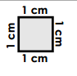
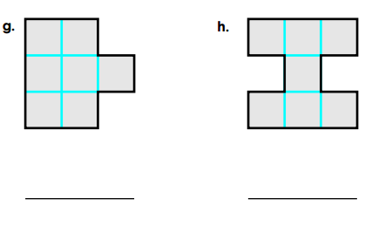

- Find the area of the following shapes:
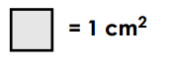
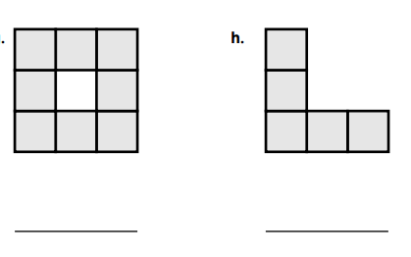

- Circle any shapes with parallel lines. “X” any shapes that have perpendicular lines.

- True or false: A rectangle is a square. Explain your answer.

